BRACT’s

Vishwakarma Institute of Technology, Pune

Practical Implementation Sheet

Department: CSE-AI Semester: 5 Academic Year: 2026-27

Division: E Batch: 1 Practical No: 9

Roll no: 42 PRN No: 12414728 Name of Student: Saachi Laturiya

Subject Name: Deep Learning

Problem Statement:

Perform image classification using a pretrained Vision Transformer (ViT) and compare its performance with a Convolutional Neural Network (CNN) using appropriate evaluation metrics.

Algorithm:
- Import the required libraries for deep learning, image processing, and performance evaluation.
- Load the Oxford-IIIT Pet dataset containing images of 37 cat and dog breeds.
- Resize and normalize the images to \(224 \times 224\) pixels.
- Divide the dataset into training and testing subsets.
- Load pretrained ResNet18 and Vision Transformer (ViT-B/16) models.
- Freeze the pretrained layers and replace the final classification layers to support 37 classes.
- Compile the training process using the Adam optimizer and cross-entropy loss.
- Train both models for two epochs using the training dataset.
- Predict the classes of test images using both models.
- Evaluate performance using accuracy, precision, recall, F1-score, and training time.
- Visualize training and testing loss, compare evaluation metrics, and plot confusion matrices.
- Display sample images with actual and predicted class labels to analyze classification performance.

Code:
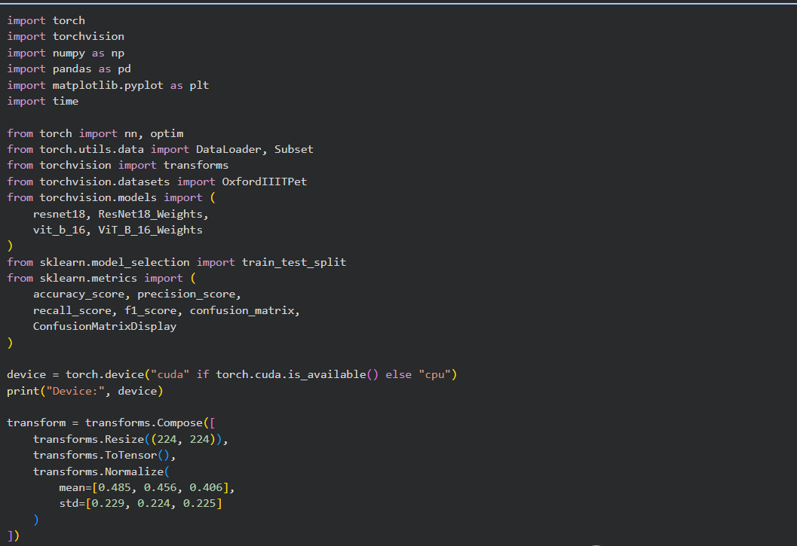
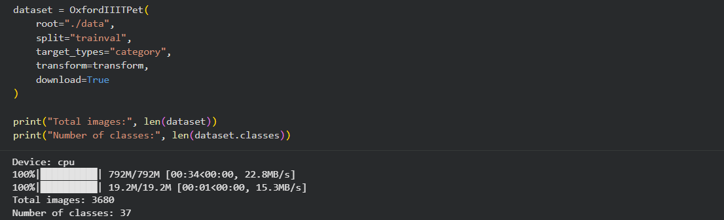
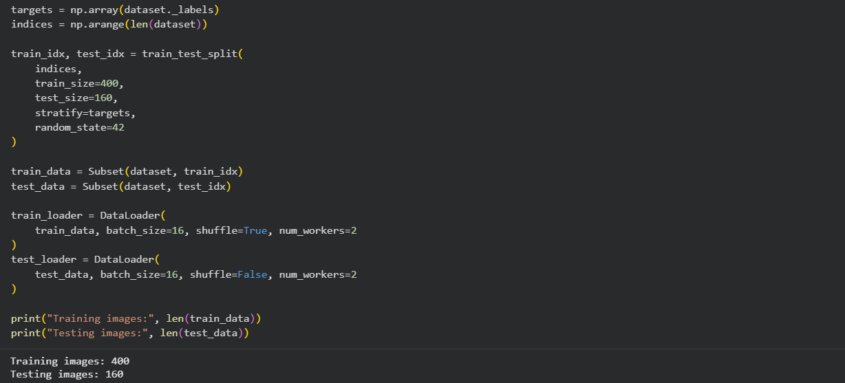
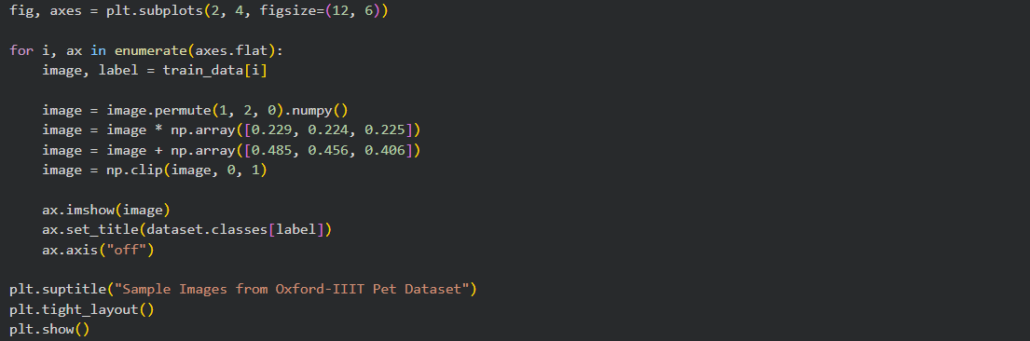
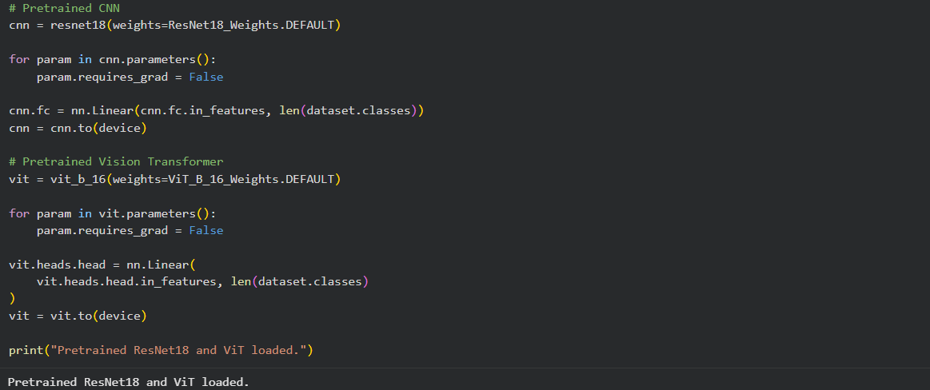
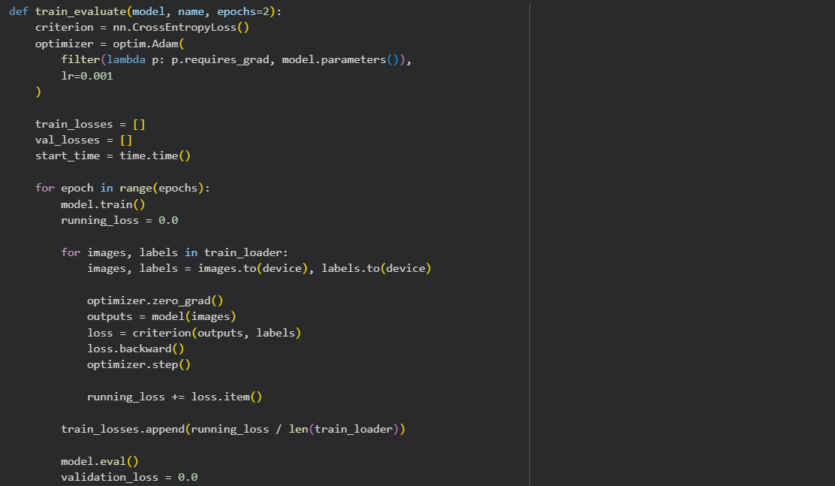
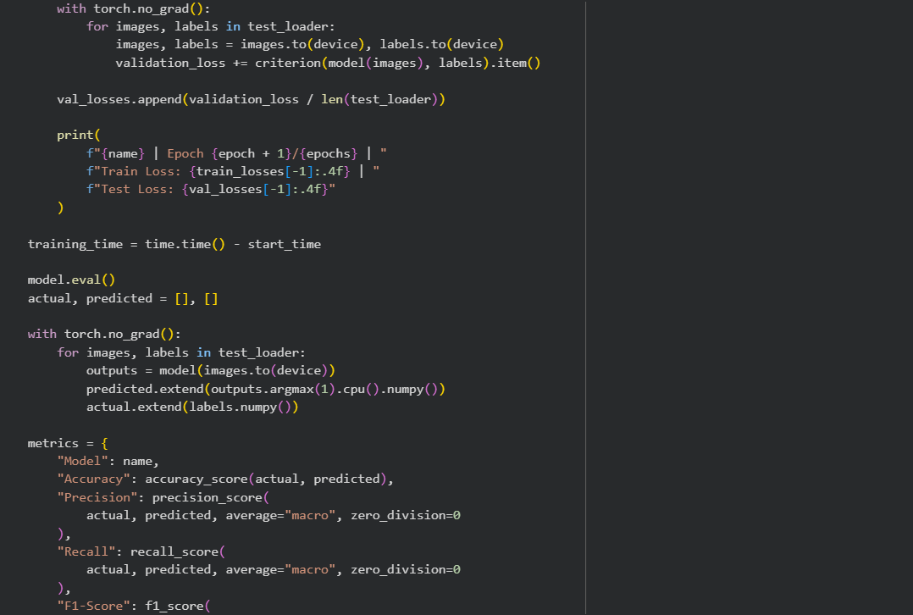
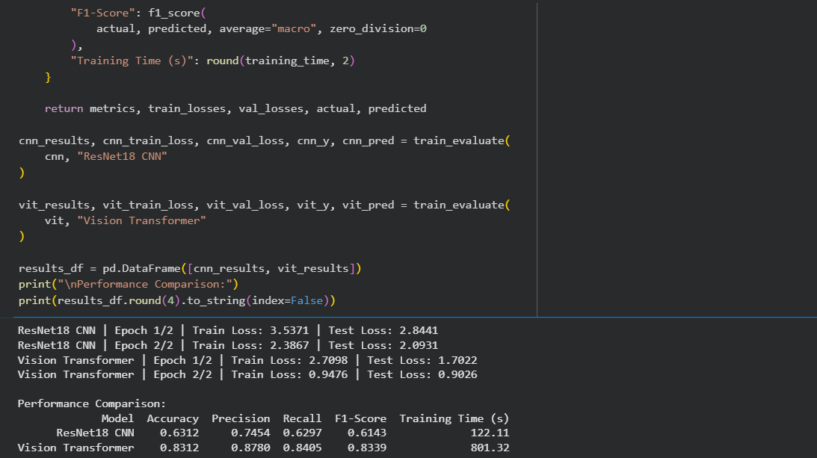
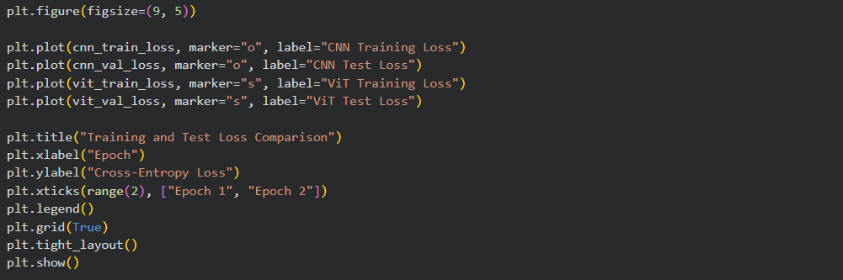
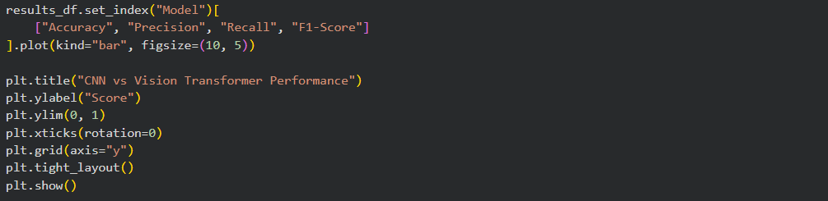
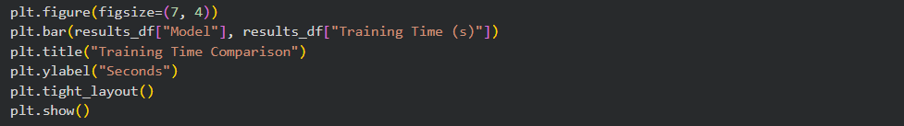
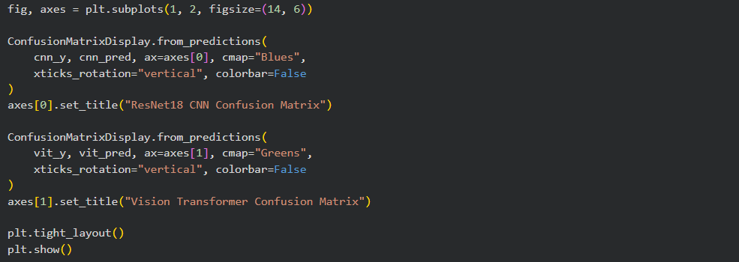
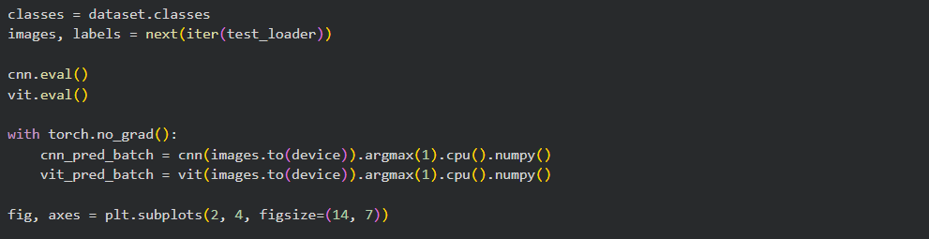
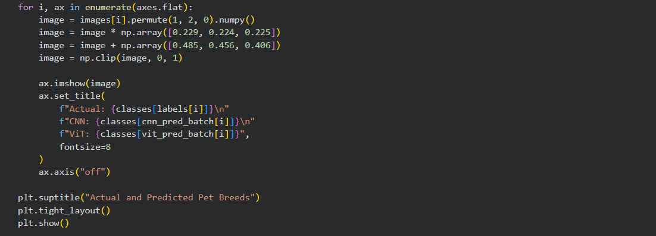

Output :

Figure 1: Sample Images from the Oxford-IIIT Pet Dataset
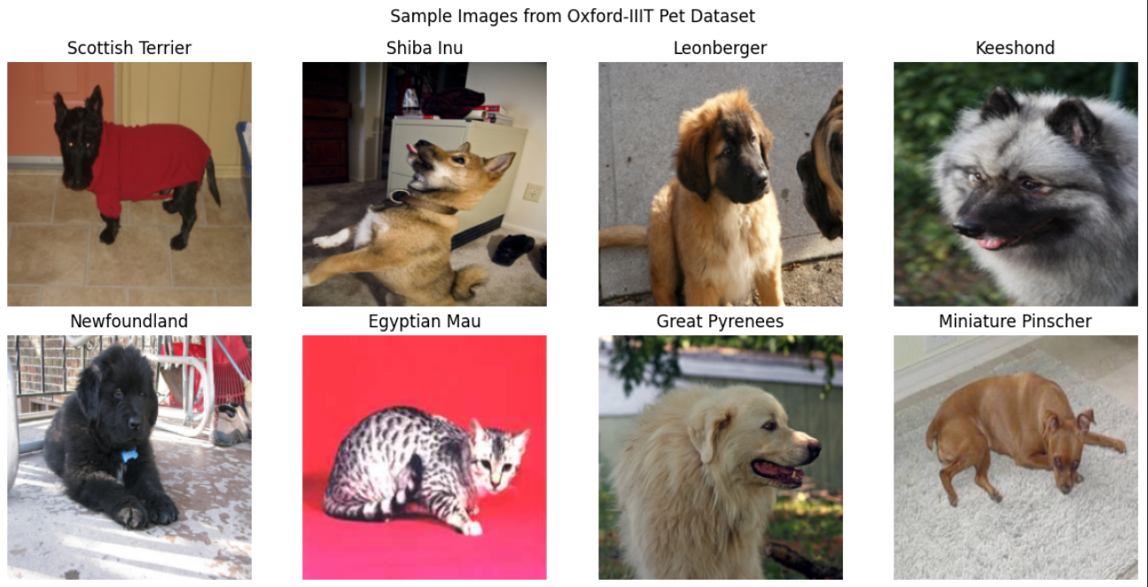

Figure 2: Training and Test Loss Comparison
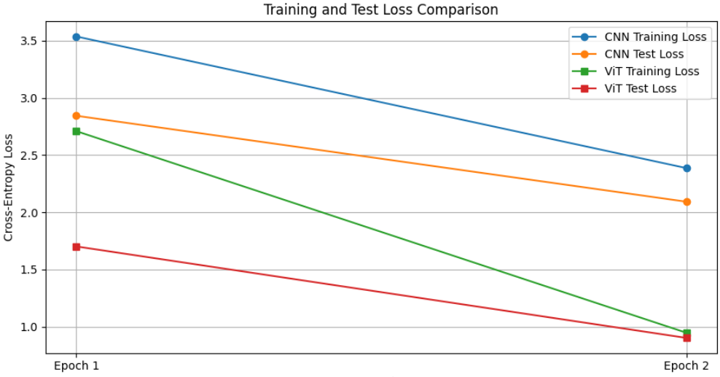
Figure 3: CNN vs. Vision Transformer Performance Comparison

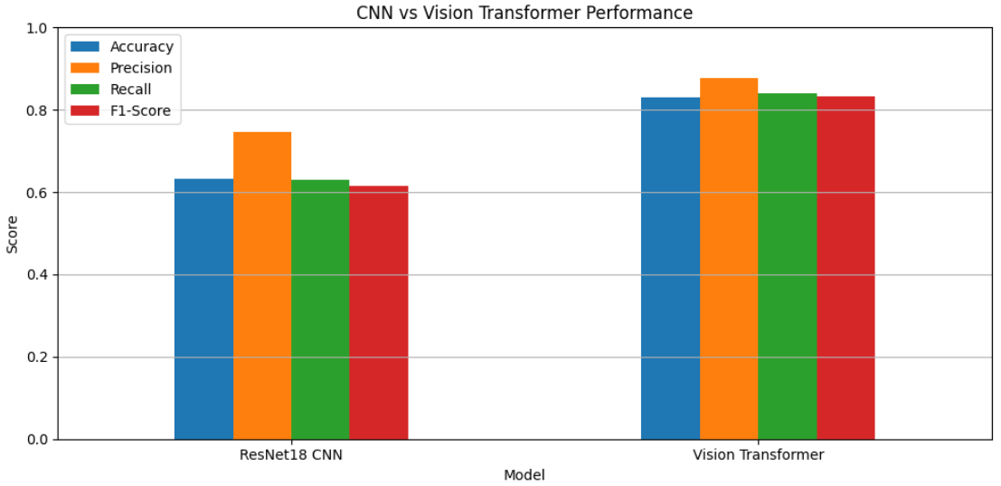

Figure 4: Training Time Comparison

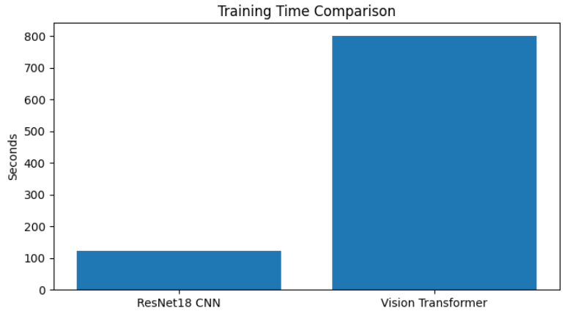

Figure 5: Confusion Matrices of ResNet18 and Vision Transformer

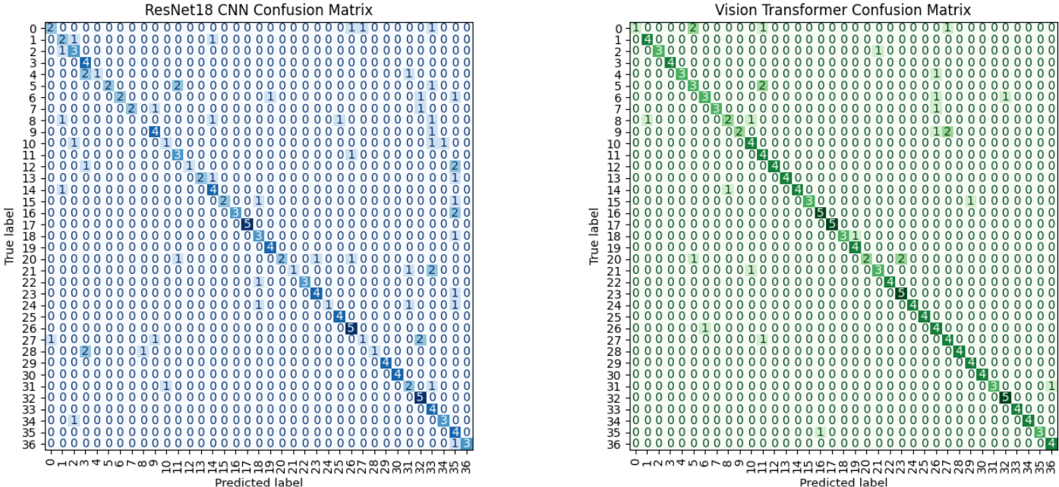

Figure 6: Actual and Predicted Pet-Breed Classification

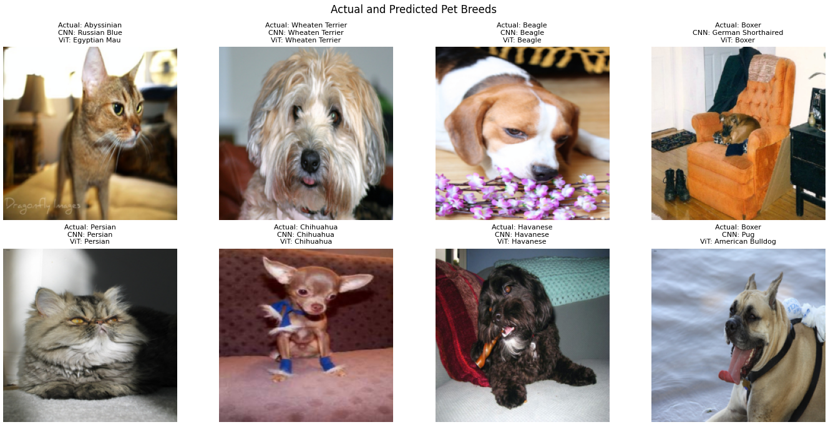

Conclusion :

A pretrained ResNet18 CNN and Vision Transformer were implemented for image classification using the Oxford-IIIT Pet dataset. Both models were trained by replacing their final classification layers while keeping the pretrained feature extraction layers frozen. Their performance was evaluated using accuracy, precision, recall, F1-score, and training time. The comparison of evaluation metrics, confusion matrices, and predicted images helps analyze the classification performance and computational requirements of both architectures.

